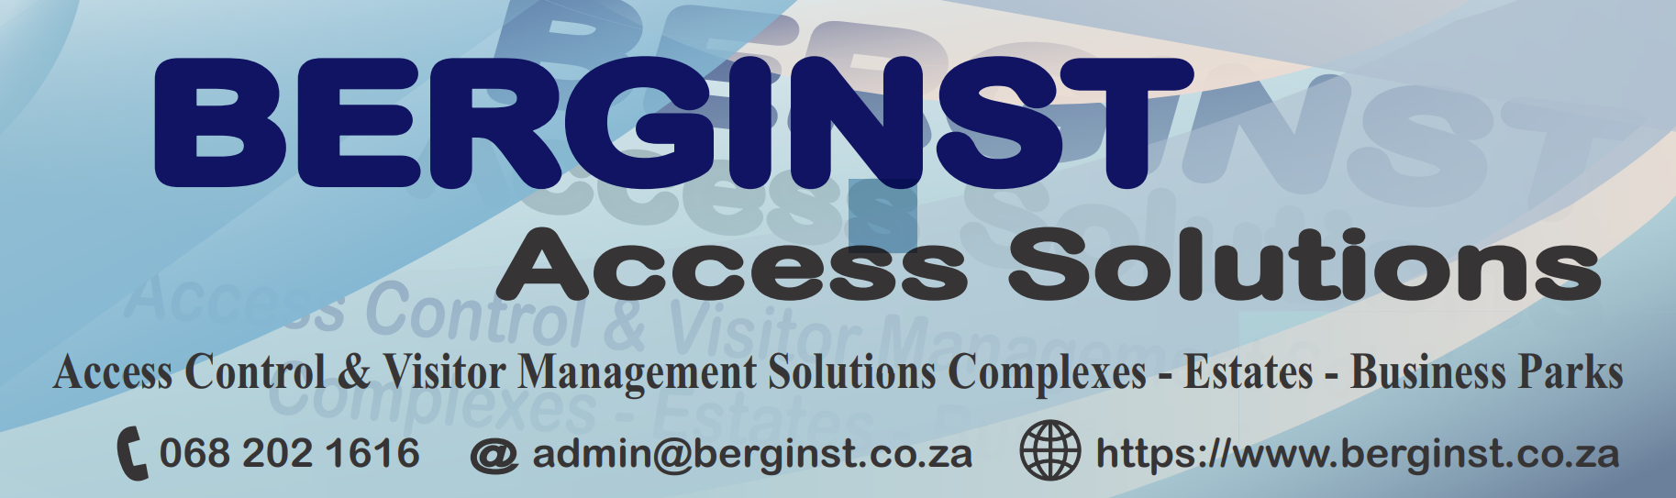

Portfolio (Web Page)
A division of Bergrivier Instrumente Kontrakteurs cc. Established in 1994 and still a leading supplier of industrial and residential technology in the access and security services market.

ABOUT
BI Contractors are proud and qualified Comb-Communications equipment installers in the Western Cape and Gauteng. In our online shop you can purchase additional Access Control equipment and accessories.

Why choose us
Supplier and solution provider since 1994, we supply and always looking for the best product for your application.

What we do
Proud INSTALLERs of Comb-Communication Equipment, Centurion, Hikvision and all related security and access solution products
Providing Superior Installation & UPGRADE & Repair service

Getting a swift and simplified quotation, with service excellence to match, has never been easier.

Access Control in your hands
Sales & Support
We have a wide range of products which can be utilized in all industries. Our professional sales team have extensive knowledge and experience in all workings of our products basket.
Installation & commissioning
With every quotation or order request we offer to tender on installation of your purchased or tendered basket. Our installation team are qualified Instrumentation and Electrical technicians with the know how to install and commission your equipment in accordance with product, national and international standards and practices.
Maintenance & repairs
We offer a maintenance contract with our quotations as proof of our trust in our products, these contracts off can take on many forms depending on your requirements. Our team are qualified maintenance people with extensive experience in all industries and major project in South Africa and abroad.
Additional access security equipment
We also supply a wide range of access control signage, equipment and accessories ranging from sensors to motors and limit switches which can be ordered online through our user friendly online-store.

WE OFFER
Product excellence and knowledge.
A specialized solution for your Access Control application.
Fast and speedy response and support via the contact us page.
A smooth online purchase experience in our online store.
Easy Installation & maintenance booking experience through our online Calendar.
A selection of pre-configured Access Control Solutions for easy and immediate online Quick Quote

FEATURES
Comb-PORTAL puts all access control in your hands
Comb MK11 Lite intercom
Comb TAP keypad
iPulse Biometric solutions
Chainway Vehicle Scanner C70
Remote loading through our Comb BT Loader
Additional security solutions and signage
Centurion Systems gate motors and boomgates
Hikvision CCTV systems
BPT home automation

