RESUME
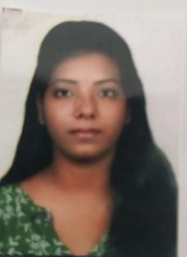

POOJA KUMARI
Email:-poojakumariii806@gmail.com Contact No:- +91 8877679001,7987089267

CAREER OBJECTIVE:-
To work with organization where there are intellectual working environment and various opp ortunities to apply and improve my knowledge and skills for the benefit of organization.

EDUCATION QUALIFICATIONS:-

SCHOOL/ DEGREE | UNIVERSITY / BOARD | YEAR | %
10TH | BSEBBOARD | 2011 | 73.80%
12TH | BSEBBOARD | 2013 | 72.40%
B.E (EEE) | RGPV(Bhopal) | 2019 | 82.00%

WORKSHOP:-
- Attended in a national level championship participation workshop ofUTKRAANTI-18 in association with NSSCIITKHARAGPUR organized bywingfotechPVT.LTD

TRAINING:-
- Done 15 days training at ''BHEL'' Bhopal in July 2018
- 3 days short team training Program on power electronics devices and THEIR -111 application in power system

TECHANICALSKILLS :-
- Micro-Processor and Microcontroller

- Electronics instrumentation

PROGRAMMING LANGUAGE :-
- TOOLS:- Ms-Word, Ms-excel
- PROGRAMMING :- C

EXTRA CURRICULAR ACTIVITIES :-
- Participatedin Drama ,Drawing & Best handwriting.

Work Experience:-
- 1 Year Experience in advisory company (B.A& SBA)
- 5 Month Experience in Brokrege company.(Choice broking& Profitmart brokrege co- mpany)

HOBBIES:-

- yoga (exercise)
- cooking
- singing
- learning different language

PERSONAL DETAILS:-
- D. O .B :-18/03/1996
- Mother's name :- MRS.SANGEETA Devi
- Father’s name :-MR. VINOD SAH
- Gender :- Female
- Blood Group :- B+
- Nationality :- India
- Language known :- Hindi, English

DECLARATION :-

I hereby declare that all the above information are true to the best of my Knowledge

Date

Place Indore(M.P)

(signature)

POOJAKUMARI

